THINK CHAMP PRIVATE LIMITED
PROJECT ON AI HEALTH SYMPTOM CHECKER
USING HTML, CSS, Flask, Python, and JSON.



SUBMITTED TO:

THE CEO OF THINKCHAMP Pvt. Lt

GURU LOKESH SIR
SUBMITTED BY:

CHEGU RAMYA KRISHNA

CONTENTS
S. No | Topic | Page No
1 | Introduction | 3
2 | History of Project | 5
3 | Requirements (Software & Hardware) | 7
4 | Objectives | 8
5 | System Architecture | 10
6 | Project Modules | 12
7 | Code Implementation | 14
8 | Screenshots / Outputs | 25
9 | Advantages | 26
10 | Future Enhancements | 27
11 | Conclusion | 29

1. INTRODUCTION
1. Introduction
The AI Health Symptom Checker is an educational software application developed as an Internship Major Project for THINK CHAMP PVT LTD. The project demonstrates the practical application of Python programming, data science libraries, and machine learning techniques to build a working, end-to-end health-symptom analysis tool.
At its core, the application accepts a description of symptoms from a user — either typed, selected from a checklist, or spoken aloud — and analyses that input using a trained machine learning classifier. The system then returns the most likely health condition associated with the reported symptoms, along with a confidence score, a short list of alternative possibilities, and a plain-language wellness suggestion. Every analysis is also rendered into a downloadable report in both plain-text and PDF form.
The project was deliberately built in two parallel, fully working forms that share the same underlying engine:
- A Flask-based web application, with user registration and login, a chatbot-style conversational interface, voice input, dark mode, a per-user history of past checks, and a public dashboard exposing the dataset and model statistics.
- A terminal (command-line) application, offering the same prediction engine, dataset analysis, and report generation through a classic menu-driven CLI experience.
This dual-interface approach was chosen specifically to demonstrate that the core logic of a machine learning application — data preparation, model training, prediction, and reporting — can and should be cleanly separated from the presentation layer. The same symptom_checker.py engine, visualizations.py charting module, and report_generator.py reporting module power both the web application and the terminal tool without any duplicated logic.
1.1 Scope of the Project
The project covers the full lifecycle of a small applied machine learning system:
- Synthetic dataset generation, designed to mimic realistic symptom-condition relationships without using any real patient data.
- Data analysis and exploration using Pandas and NumPy.
- Visualization of patterns in the data using Matplotlib and Seaborn.
- Training, evaluating, and persisting a classification model using scikit-learn.
- Building a natural-language symptom parser that converts free-text or spoken input into model-ready features.
- Generating downloadable, professional health reports in TXT and PDF formats.
- Building a complete, styled, multi-page web application around the engine, with authentication, real-time prediction, and an optional generative-AI integration.
- Building a parallel terminal application exposing the same capabilities.

Features
- User Registration/Login
- Free-text symptom input
- Automatic symptom extraction using NLP
- Disease prediction
- Confidence percentage
- Severity assessment
- Suggested precautions
- Medication guidance (general information only)
- Nearby specialist recommendation (optional)
- Medical history storage
- Prediction history dashboard
- Charts and analytics
- Responsive web interface

2. HISTORY OF PROJECT
History of AI Health Symptom Checkers
The concept of computerized symptom checking dates back to the 1960s and 1970s, when researchers began developing computer-based medical decision support systems to assist physicians with diagnosis. One of the earliest influential systems was MYCIN, developed at Stanford University in the 1970s. MYCIN used rule-based reasoning to recommend treatments for bacterial infections and demonstrated that computers could support clinical decision-making, although it was designed for healthcare professionals rather than patients. (pmc.ncbi.nlm.nih.gov)
During the 1980s and 1990s, advances in expert systems led to the development of additional clinical decision support tools. These systems relied on predefined medical rules and knowledge bases created by experts. While useful in specific domains, they required extensive manual updates and could not easily adapt to new medical knowledge.
In the 2000s, increasing internet access enabled online symptom checkers for the general public. These web-based tools allowed users to enter symptoms and receive lists of possible conditions along with advice about whether to seek medical care. Their goal was to improve access to health information and encourage appropriate healthcare utilization. (pmc.ncbi.nlm.nih.gov)
The 2010s saw major advances due to Machine Learning (ML) and Natural Language Processing (NLP). Instead of relying only on fixed rules, symptom checkers began learning from large medical datasets, enabling improved disease prediction, free-text symptom analysis, and more personalized recommendations.
Today, modern AI symptom checkers combine:
- Machine Learning for disease prediction
- Natural Language Processing for understanding user-entered symptoms
- Clinical knowledge bases
- Risk assessment and triage recommendations
- Cloud computing and mobile applications for widespread accessibility
Many healthcare organizations and technology companies now provide AI-assisted symptom assessment tools. These systems are designed to support—not replace—medical professionals by helping users decide when to seek care.

Year | Development
1970s | Early AI-based medical expert systems such as MYCIN demonstrated that computers could assist clinicians with diagnosis and treatment recommendations using rule-based reasoning. (ARISE)
1980s–1990s | Clinical Decision Support Systems (CDSS) expanded in hospitals, using knowledge-based rules to help healthcare professionals make diagnostic and treatment decisions. (ARISE)
2000s | Public web-based symptom checkers became widely available, allowing users to enter symptoms online and receive possible conditions and triage advice. (iatroX)
2010–2015 | Machine Learning (ML) and Natural Language Processing (NLP) began improving symptom analysis, enabling more accurate disease prediction and free-text symptom understanding. (UI Bakery)
2016–2019 | AI-powered mobile health applications integrated symptom checking with telemedicine, electronic health records, and personalized healthcare recommendations. (UI Bakery)
2020–2022 | The COVID-19 pandemic accelerated adoption of AI symptom checkers for preliminary screening, remote triage, and virtual healthcare support worldwide. (ARISE)
2023–2024 | Generative AI and Large Language Models (LLMs) enhanced conversational symptom assessment, multilingual support, and personalized health guidance while emphasizing that AI should not replace professional medical diagnosis. (ARISE)
2025 | Modern symptom checkers increasingly combined AI, ML, NLP, cloud computing, wearable-device integration, and telehealth to provide more comprehensive health assessments and care navigation. (Xfactr.ai)
2026 | Advanced conversational AI symptom checkers support natural-language interviews, personalized risk assessment, integration with wearable devices, and clinician-assisted workflows. Current research focuses on improving diagnostic accuracy, safety, explainability, and seamless integration into healthcare systems, while emphasizing that these tools provide guidance rather than definitive diagnoses. (arxiv.org)

3. REQUIREMENTS
Category | Requirement
Operating System | Windows 10/11, Linux (Ubuntu 20.04+), macOS
Programming Language | Python 3.10 or later
Backend Framework | Flask
Frontend | HTML5, CSS3, Bootstrap 5, JavaScript
Database | SQLite / MySQL
Machine Learning Library | Scikit-learn
Data Processing Libraries | NumPy, Pandas
NLP Library | NLTK or spaCy
Visualization Library | Matplotlib
Development Tools | Visual Studio Code / PyCharm, Git
Web Browser | Google Chrome, Microsoft Edge, Mozilla Firefox
Processor | Intel Core i3/i5 or AMD Ryzen 3/5 (or higher)
RAM | Minimum 4 GB (8 GB recommended)
Storage | Minimum 10 GB free disk space
Internet | Required for package installation and updates
4. OBJECTIVES
The primary objective of the AI Health Symptom Checker is to develop an intelligent healthcare application that assists users in identifying possible diseases based on the symptoms they experience. The system leverages Artificial Intelligence (AI), Machine Learning (ML), and Natural Language Processing (NLP) to analyze user-provided symptoms and generate accurate, fast, and reliable preliminary health assessments. The application is intended to support early health awareness and encourage timely consultation with healthcare professionals; it is not designed to replace medical diagnosis or treatment.
A key objective is to enable users to enter symptoms either as individual selections or in free-text form. The system automatically extracts relevant medical symptoms using NLP techniques and converts them into structured data suitable for machine learning models. This improves usability by allowing users to describe their symptoms in natural language rather than selecting only predefined options.
Another important objective is to improve disease prediction accuracy by employing supervised machine learning algorithms such as Random Forest, Decision Tree, Support Vector Machine (SVM), K-Nearest Neighbors (KNN), and Naïve Bayes. These algorithms analyze symptom patterns and estimate the most likely health conditions along with a confidence score, helping users understand the probability of each prediction.
The system also aims to provide personalized health recommendations based on the predicted condition. These recommendations may include self-care guidance, preventive measures, general lifestyle advice, and indications of when medical attention should be sought. For severe or high-risk symptom combinations, the application can advise users to seek immediate emergency care.
An additional objective is to improve healthcare accessibility by offering a web-based platform that is available at any time and can be accessed from desktops, laptops, tablets, or smartphones.
The project further aims to maintain secure storage of user information, symptom history, and prediction records using a database system. This enables users to review previous assessments while supporting data management and future system enhancements. Appropriate security measures should be implemented to help protect user privacy and sensitive health information.
Another objective is to provide a simple, interactive, and user-friendly interface that enables users of different technical backgrounds to navigate the application with ease. Clear presentation of predictions, confidence scores, severity levels, and health recommendations enhances the overall user experience.
Finally, the AI Health Symptom Checker seeks to demonstrate how modern AI technologies can assist in healthcare by providing fast preliminary assessments, supporting informed health decisions, reducing unnecessary hospital visits for minor illnesses, and encouraging timely medical consultation for serious conditions.
Accept symptoms from a user through multiple input methods: typed free text, a selectable checklist, and spoken voice input.
- Process and analyze a structured health dataset using Pandas and NumPy, surfacing meaningful statistics such as symptom frequency and condition distribution.
- Train a supervised machine learning classifier capable of predicting a likely health condition from a set of reported symptoms, together with a calibrated confidence score.
- Visualize the relationships within the dataset using Matplotlib and Seaborn, including bar charts, pie charts, a correlation heatmap, and a distribution plot.
- Generate a clear, professional, downloadable health report — in both plain text and PDF — after every symptom check.
- Provide AI-generated, general wellness suggestions for each predicted condition, default to safe pre-written templates, and only generate this text live through a third-party AI service when explicitly enabled and protected by a safety filter.
- Build a complete, secure, user-friendly web interface around the engine, including authentication, a conversational chatbot-style interaction model, dark mode, and real-time results.
- Build an equally complete terminal application exposing the same engine, demonstrating that the core logic is reusable and presentation-agnostic.
- Maintain transparency and safety throughout — clearly labeling the dataset as synthetic, disclosing whenever AI-generated text is used instead of a static template, and never allowing the system to present its output as a substitute for professional medical advice.

5. SYSTEM ARCHITECTURE
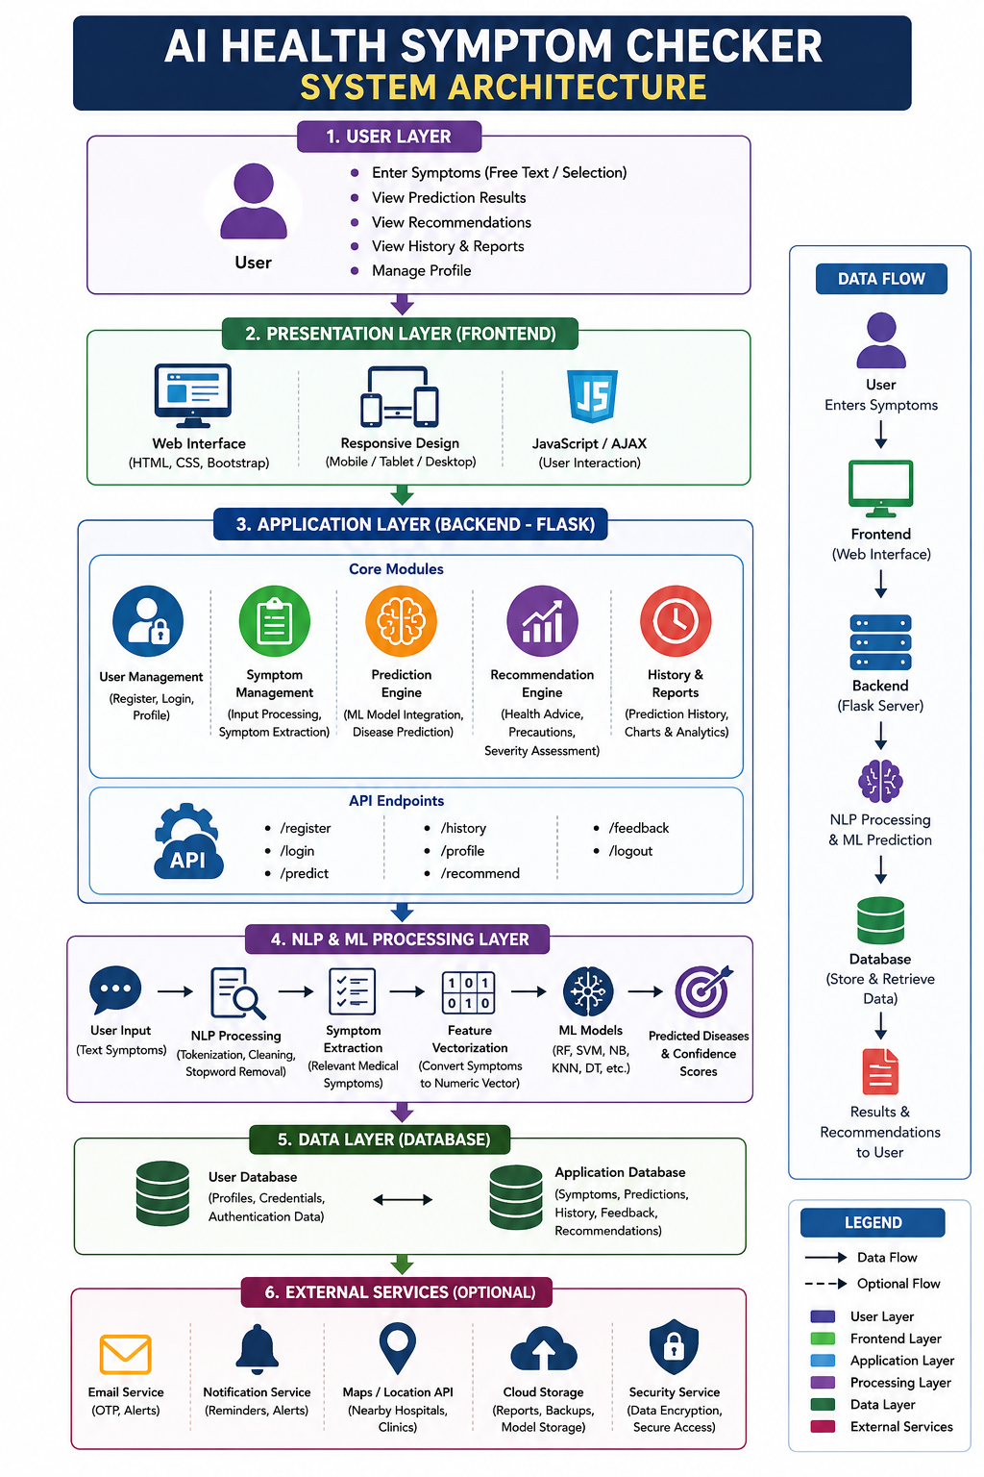
Workflow
- User Registration/Login
The user creates an account or logs into the system securely.
- Symptom Input
The user enters symptoms through text input or selects symptoms from a predefined list.
- DataValidation
The system validates the entered symptoms and removes invalid or duplicate inputs.
- NLP Preprocessing
The text is cleaned through tokenization, stop-word removal, punctuation removal, and normalization.
- Symptom Extraction
Relevant medical symptoms are identified and converted into standardized symptom names.
- Feature Vector Generation
The extracted symptoms are transformed into numerical feature vectors suitable for machine learning models.
- Disease Prediction
The trained Machine Learning model analyzes the symptoms and predicts the most likely disease(s).
- Confidence Score Calculation
The system calculates the probability or confidence score for each predicted disease.
- Severity Assessment
The predicted condition is classified into Low, Moderate, or High severity based on symptoms and confidence.
- Recommendation Generation
The system provides health precautions, self-care suggestions, and guidance on whether to consult a doctor or seek emergency care.
- Result Display
The predicted disease, confidence score, severity level, and recommendations are displayed to the user.
- Data Storage
User details, symptoms, predictions, and reports are securely stored in the database for future reference.
- History & Reports
Users can view previous predictions, download reports, and track their health assessment history.
6. PROJECT MODULES
The AI Health Symptom Checker is divided into several functional modules that work together to provide accurate disease prediction, health recommendations, and efficient data management. Each module performs a specific task, ensuring the overall system operates smoothly and delivers reliable preliminary health assessments.

1. User Authentication Module
This module manages user registration, login, and secure authentication. It verifies user credentials, protects personal information, and ensures that only authorized users can access the application. Password encryption and session management enhance the security of the system.

2. User Profile Module
The User Profile Module stores personal information such as name, age, gender, contact details, and medical history. Maintaining user profiles enables personalized health assessments and allows users to access their previous records and reports.

3. Symptom Input Module
This module allows users to enter their symptoms either by typing them in natural language or by selecting them from a predefined symptom list. It serves as the primary interface for collecting health-related information required for disease prediction.

4. NLP Processing Module
The Natural Language Processing (NLP) module processes the user's input by performing text cleaning, tokenization, stop-word removal, normalization, and keyword identification. It converts unstructured text into structured data suitable for machine learning analysis.

5. Symptom Extraction Module
The Symptom Extraction Module identifies and extracts medically relevant symptoms from the processed text. It maps synonyms and similar expressions to standardized medical symptom terms, improving prediction accuracy.

6. Feature Engineering Module
This module transforms the extracted symptoms into numerical feature vectors that can be processed by machine learning algorithms. Proper feature engineering enhances model performance and prediction reliability.

7. Disease Prediction Module
The Disease Prediction Module is the core component of the system. It applies trained machine learning algorithms such as Random Forest, Support Vector Machine (SVM), Decision Tree, K-Nearest Neighbors (KNN), or Naïve Bayes to predict the most probable disease based on the user's symptoms.

8. Confidence Score Module
After prediction, this module calculates the confidence or probability score for each predicted disease. The confidence score helps users understand how strongly the model supports each prediction.

9. Severity Assessment Module
This module evaluates the seriousness of the predicted condition by analyzing symptom combinations and prediction confidence. It classifies the health condition into Low, Moderate, or High severity and assists in determining the urgency of medical attention.

10. Recommendation Module
Based on the predicted disease and severity level, this module generates personalized health recommendations, precautionary measures, lifestyle suggestions, and guidance on whether the user should seek medical consultation or emergency care.

11. Results Dashboard Module
The Results Dashboard presents the predicted disease, confidence score, severity level, and health recommendations in a clear and user-friendly format. It may also include charts, health summaries, and downloadable reports for better understanding.

12. Database Management Module
This module securely stores user information, symptom records, prediction history, recommendations, and feedback. Efficient database management enables quick retrieval of information while supporting data privacy and system performance.

13. History and Reports Module
The History and Reports Module allows users to review previous health assessments, monitor changes over time, and download reports for future reference or consultation with healthcare professionals.

14. Admin Module
The Admin Module provides administrative control over the application. It enables administrators to manage user accounts, update disease and symptom datasets, monitor system performance, review prediction logs, maintain machine learning models, and ensure the smooth operation of the entire AI Health Symptom Checker system.

Code
Sample code
import os, json, uuid
from datetime import datetime
from functools import wraps
from flask import (Flask, render_template, request, redirect,
url_for, session, flash, jsonify, send_file)
from werkzeug.security import generate_password_hash, check_password_hash

from symptom_checker import analyze_text, extract_symptoms, train_model
from visualizations import confidence_bar_chart, symptom_radar_chart, history_trend_chart
from report_generator import generate_txt_report, generate_pdf_report
from huggingface_helper import chatbot_reply, hf_enhance_prediction
from openai_engine import (openai_analyze, openai_chatbot_reply,
ai_realtime_extract, engine_status, is_openai_ready)

app = Flask(__name__)
app.secret_key = "ramya-ai-health-secret-2024"
DB_FILE = "users_db.json"

# ── DB ────────────────────────────────────────────────────────────────────────
def load_db():
if not os.path.exists(DB_FILE): return {}
with open(DB_FILE) as f: return json.load(f)

def save_db(db):
with open(DB_FILE,"w") as f: json.dump(db,f,indent=2)

def login_required(f):
@wraps(f)
def dec(*a,**k):
if "username" not in session:
flash("Please log in to continue.","warning")
return redirect(url_for("login"))
return f(*a,**k)
return dec

# ── Auth ──────────────────────────────────────────────────────────────────────
@app.route("/")
def index():
status = engine_status()
return render_template("index.html", engine_status=status)

@app.route("/register", methods=["GET","POST"])
def register():
if request.method == "POST":
u = request.form.get("username","").strip()
e = request.form.get("email","").strip()
p = request.form.get("password","")
db = load_db()
if not u or not e or not p: flash("All fields required.","error")
elif u in db: flash("Username taken.","error")
elif len(p) < 6: flash("Password min 6 chars.","error")
else:
db[u] = {"email":e,"password":generate_password_hash(p),
"created":datetime.now().isoformat(),
"history":[],"chat_history":[]}
save_db(db); session["username"] = u
flash("Account created! Welcome.","success")
return redirect(url_for("dashboard"))
return render_template("register.html")

@app.route("/login", methods=["GET","POST"])
def login():
if request.method == "POST":
u = request.form.get("username","").strip()
p = request.form.get("password","")
db = load_db(); user = db.get(u)
if user and check_password_hash(user["password"],p):
session["username"] = u
flash(f"Welcome back, {u}!","success")
return redirect(url_for("dashboard"))
flash("Invalid credentials.","error")
return render_template("login.html")

@app.route("/logout")
def logout():
session.clear(); flash("Logged out.","info")
return redirect(url_for("index"))

# ── Dashboard ─────────────────────────────────────────────────────────────────
@app.route("/dashboard")
@login_required
def dashboard():
db = load_db(); user = db.get(session["username"],{})
history = user.get("history",[])
chart_path = None
if history:
chart_path = history_trend_chart(history, filename=f"history_{session['username']}.png")
return render_template("dashboard.html",
username=session["username"], history=history,
recent=history[-5:][::-1], chart_path=chart_path,
total_checks=len(history), engine_status=engine_status())

# ── Checker ───────────────────────────────────────────────────────────────────
@app.route("/checker", methods=["GET","POST"])
@login_required
def checker():
result = None; symptom_text = ""; conf_chart = radar_chart = None
engine_used = "local"

if request.method == "POST":
symptom_text = request.form.get("symptoms","").strip()
force_engine = request.form.get("engine","auto") # auto | openai | local

if symptom_text:
# ── Choose engine ──────────────────────────────────────────────
use_openai = (force_engine == "openai") or \
(force_engine == "auto" and is_openai_ready())

if use_openai:
result = openai_analyze(symptom_text)
engine_used = "openai"
# If OpenAI fails hard, fall back to local
if result and result.get("error") == "openai_unavailable":
result = analyze_text(symptom_text)
engine_used = "local"
else:
result = analyze_text(symptom_text)
engine_used = "local"

if result and "error" not in result:
# HF cross-verification (always try)
result = hf_enhance_prediction(symptom_text, result)
result["engine_used"] = engine_used

# Charts
conf_chart = os.path.basename(
confidence_bar_chart(result["top3"], f"conf_{session['username']}.png"))
radar_chart = os.path.basename(
symptom_radar_chart(result["matched_symptoms"], [],
f"radar_{session['username']}.png"))
# Save history
db = load_db()
entry = {
"id": str(uuid.uuid4())[:8],
"date": datetime.now().strftime("%Y-%m-%d %H:%M"),
"symptoms_text": symptom_text,
"matched_symptoms": result.get("matched_symptoms",[]),
"disease": result.get("disease","Unknown"),
"confidence": result.get("confidence_pct","N/A"),
"urgency": result.get("urgency","medium"),
"engine": engine_used,
}
db[session["username"]]["history"].append(entry)
session["last_disease"] = result.get("disease")
session["last_result"] = json.dumps(result)
save_db(db)

return render_template("checker.html",
result=result, symptom_text=symptom_text,
conf_chart=conf_chart, radar_chart=radar_chart,
engine_used=engine_used, openai_ready=is_openai_ready(),
engine_status=engine_status())

# ── Real-time AJAX ────────────────────────────────────────────────────────────
@app.route("/api/realtime", methods=["POST"])
@login_required
def api_realtime():
data = request.get_json() or {}
text = data.get("text","").strip()
if len(text) < 6:
return jsonify({"symptoms":[],"partial":True})
# Prefer AI extraction if available
if is_openai_ready():
symptoms = ai_realtime_extract(text)
else:
symptoms = extract_symptoms(text)
return jsonify({"symptoms": symptoms, "count": len(symptoms),
"partial": True, "engine": "openai" if is_openai_ready() else "local"})

# ── History ───────────────────────────────────────────────────────────────────
@app.route("/history")
@login_required
def history():
db = load_db()
user_history = db.get(session["username"],{}).get("history",[])[::-1]
return render_template("history.html", history=user_history)

@app.route("/history/delete/<eid>", methods=["POST"])
@login_required
def delete_history(eid):
db = load_db(); user = db.get(session["username"])
if user:
user["history"] = [h for h in user["history"] if h.get("id") != eid]
save_db(db); flash("Entry deleted.","success")
return redirect(url_for("history"))

# ── Chatbot ───────────────────────────────────────────────────────────────────
@app.route("/chatbot")
@login_required
def chatbot():
db = load_db()
chat_history = db.get(session["username"],{}).get("chat_history",[])[-20:]
return render_template("chatbot.html",
last_disease=session.get("last_disease"),
chat_history=chat_history,
openai_ready=is_openai_ready())

@app.route("/api/chat", methods=["POST"])
@login_required
def api_chat():
data = request.get_json() or {}
msg = data.get("message","").strip()
if not msg: return jsonify({"error":"Empty"}), 400

disease = session.get("last_disease")
db = load_db()
raw_history = db.get(session["username"],{}).get("chat_history",[])

# Use GPT chatbot if available, else rule-based
if is_openai_ready():
reply = openai_chatbot_reply(msg, disease, raw_history)
engine = "openai"
else:
reply = chatbot_reply(msg, disease)
engine = "local"

# Persist
if session["username"] in db:
ch = db[session["username"]].setdefault("chat_history",[])
ch.append({"role":"user","text":msg, "time":datetime.now().strftime("%H:%M")})
ch.append({"role":"bot", "text":reply, "time":datetime.now().strftime("%H:%M"),"engine":engine})
db[session["username"]]["chat_history"] = ch[-100:]
save_db(db)

return jsonify({"reply":reply,"disease_context":disease,"engine":engine})

@app.route("/api/chat/clear", methods=["POST"])
@login_required
def clear_chat():
db = load_db()
if session["username"] in db:
db[session["username"]]["chat_history"] = []
save_db(db)
return jsonify({"status":"cleared"})

# ── Engine status API ─────────────────────────────────────────────────────────
@app.route("/api/engine/status")
@login_required
def api_engine_status():
return jsonify(engine_status())

@app.route("/api/engine/set-key", methods=["POST"])
@login_required
def api_set_key():
"""Allow users to set their own OpenAI key from the UI (session-only)."""
data = request.get_json() or {}
key = data.get("api_key","").strip()
if key.startswith("sk-") and len(key) > 20:
os.environ["OPENAI_API_KEY"] = key
# Reset client so it picks up the new key
import openai_engine as oe
oe.OPENAI_API_KEY = key
oe._client = None
session["openai_key_set"] = True
return jsonify({"status":"ok","message":"OpenAI API key activated for this session."})
return jsonify({"status":"error","message":"Invalid API key format."}), 400

# ── Reports ───────────────────────────────────────────────────────────────────
@app.route("/report/txt", methods=["POST"])
@login_required
def download_txt():
try: result = json.loads(request.form.get("result_json","{}"))
except: flash("Report error.","error"); return redirect(url_for("checker"))
path = generate_txt_report(result, session["username"])
return send_file(path, as_attachment=True, download_name="health_report.txt")

@app.route("/report/pdf", methods=["POST"])
@login_required
def download_pdf():
try: result = json.loads(request.form.get("result_json","{}"))
except: flash("Report error.","error"); return redirect(url_for("checker"))
path = generate_pdf_report(result, session["username"])
if path: return send_file(path, as_attachment=True, download_name="health_report.pdf")
flash("PDF unavailable, downloading TXT.","warning")
path = generate_txt_report(result, session["username"])
return send_file(path, as_attachment=True, download_name="health_report.txt")

# ── Charts ────────────────────────────────────────────────────────────────────
@app.route("/charts/<filename>")
@login_required
def serve_chart(filename):
return send_file(os.path.join("charts", filename))

@app.route("/api/analyze", methods=["POST"])
def api_analyze():
data = request.get_json() or {}
text = data.get("text","")
if not text: return jsonify({"error":"No text"}), 400
if is_openai_ready():
return jsonify(openai_analyze(text))
return jsonify(analyze_text(text))

# ── Startup ───────────────────────────────────────────────────────────────────
if __name__ == "__main__":
if not os.path.exists("dataset.csv"):
import subprocess; subprocess.run(["python","build_dataset.py"])
if not os.path.exists("model.pkl"):
train_model()
st = engine_status()
print(f"\n{'='*55}")
print(f" 🩺 AI Health Symptom Checker")
print(f" OpenAI (GPT-4o-mini): {'✅ READY' if st['openai_ready'] else '❌ No API key — using local ML'}")
print(f" Local ML fallback: ✅ Ready")
print(f" Set key: export OPENAI_API_KEY=sk-...")
print(f"{'='*55}\n")
app.run(debug=True, host="0.0.0.0", port=5000)

- SCREENSHOTS (OUTPUT)

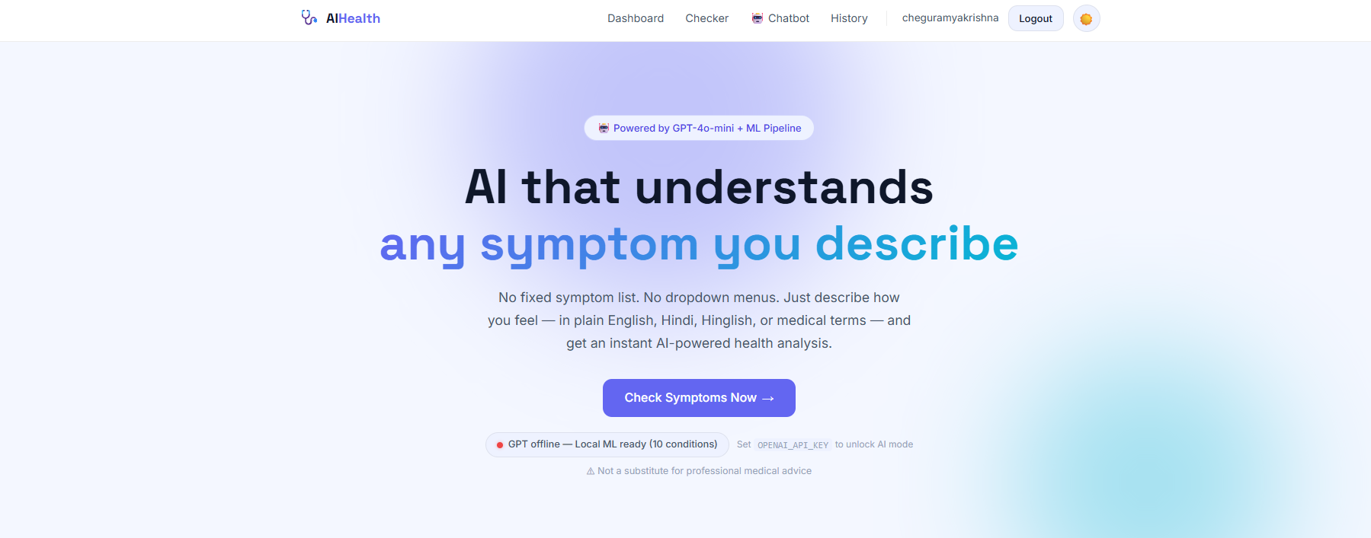
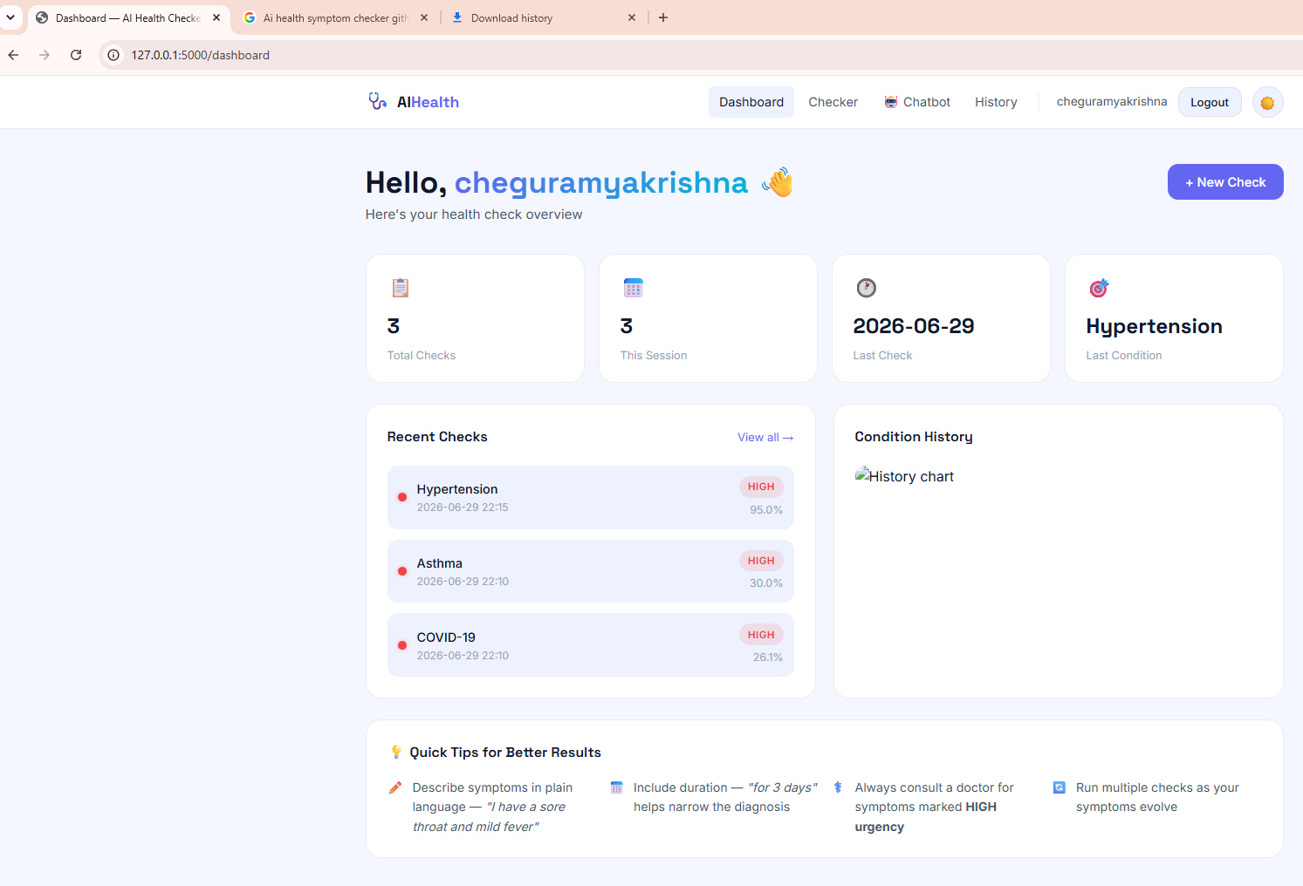

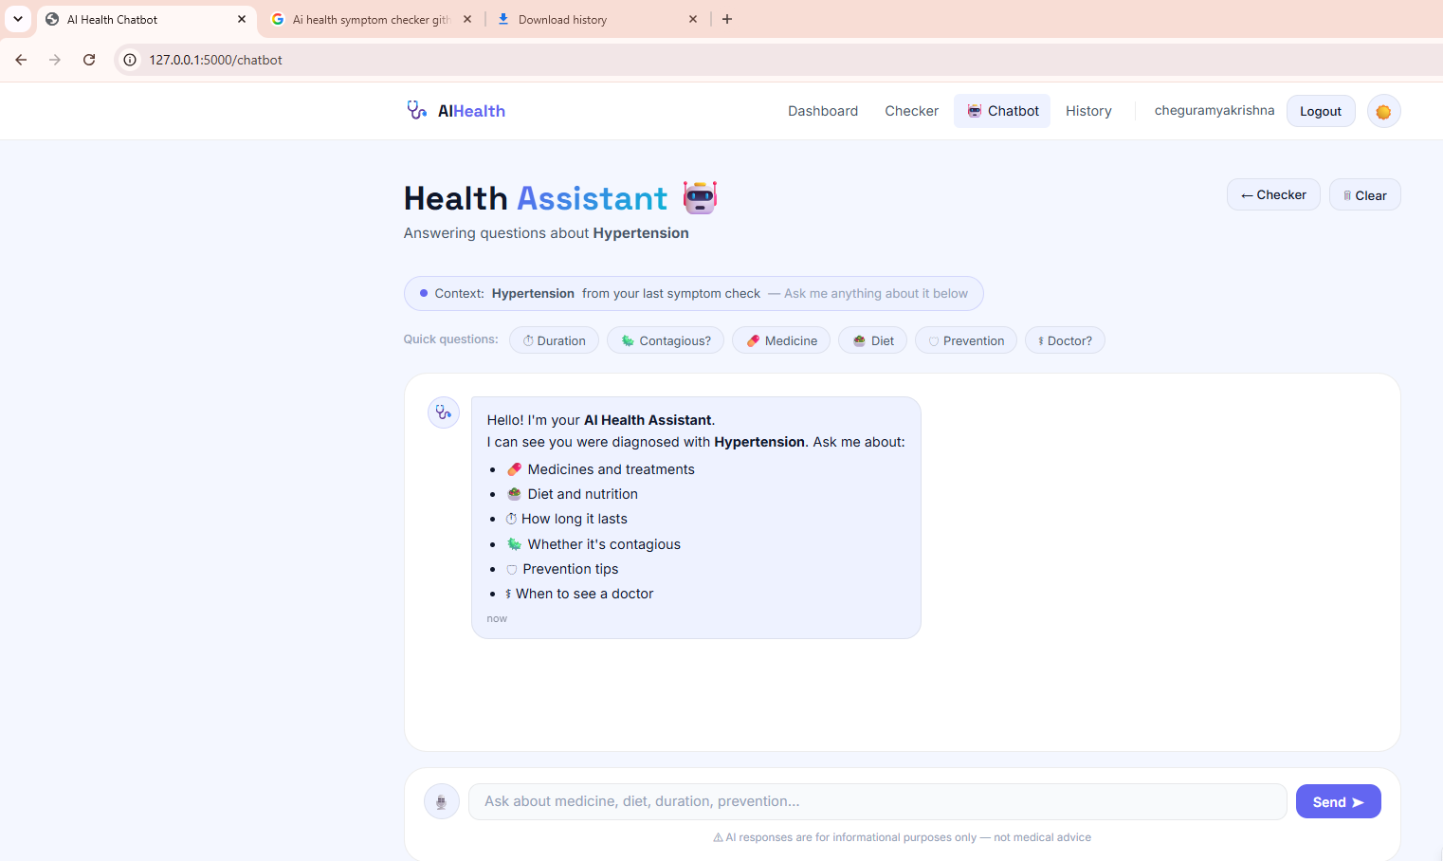

- ADVANTAGES
- Easy to use.
- Fast response generation.
- User-friendly interface.
- Reduces manual effort.
- Available 24/7.
- Supports automated communication.
- Scalable for future improvements.

10. FUTURE ENHANCEMENTS
The AI Health Symptom Checker can be significantly enhanced by incorporating advanced Artificial Intelligence technologies, real-time healthcare services, and improved user-centric features. Future versions of the system can provide more accurate disease prediction, personalized healthcare recommendations, and seamless integration with modern digital health ecosystems.
One important enhancement is the integration of Large Language Models (LLMs) and advanced Generative AI to enable more natural and interactive conversations with users. Instead of relying only on predefined symptom lists, the system could understand detailed patient descriptions, ask intelligent follow-up questions, and generate more personalized health guidance while improving the overall user experience.
The accuracy of disease prediction can be further improved by training machine learning models on larger, more diverse, and clinically validated medical datasets. Incorporating deep learning techniques and ensemble learning methods can help the system recognize complex symptom patterns and improve prediction performance across a wider range of diseases.
Another significant enhancement is the integration of wearable health devices such as smartwatches and fitness trackers. By collecting real-time health parameters including heart rate, blood pressure, blood oxygen saturation (SpO₂), body temperature, sleep quality, and physical activity, the system can provide continuous health monitoring and generate more accurate risk assessments.
Future versions can also support telemedicine integration, enabling users to schedule online consultations with healthcare professionals directly through the application. Secure sharing of symptom reports and prediction results with doctors would improve communication and assist clinicians during patient evaluation.
The application can be enhanced with Electronic Health Record (EHR) integration, allowing authorized healthcare providers to access patient history, laboratory reports, prescribed medications, allergies, and previous diagnoses. This would support more comprehensive and personalized healthcare recommendations while maintaining appropriate privacy and security controls.
Another valuable enhancement is multilingual support using advanced NLP techniques. Supporting multiple regional and international languages would make the application more accessible to users from different linguistic backgrounds and improve healthcare accessibility in rural and underserved communities.
Future development can also include advanced security features such as multi-factor authentication, end-to-end encryption, secure cloud storage, and privacy-preserving AI techniques to protect sensitive health information and comply with healthcare data protection regulations.
The system can additionally provide medication reminders, vaccination schedules, appointment notifications, emergency contact alerts, nutrition guidance, mental health screening, and personalized wellness recommendations. Integration with cloud computing and mobile platforms would further improve scalability, availability, and accessibility.
In conclusion, these future enhancements will transform the AI Health Symptom Checker into a comprehensive intelligent healthcare platform capable of delivering more accurate disease prediction, real-time health monitoring, personalized medical guidance, secure healthcare data management, and improved digital healthcare services while continuing to support, rather than replace, professional medical diagnosis and treatment.

11. CONCLUSION
The AI Health Symptom Checker demonstrates how Artificial Intelligence (AI), Machine Learning (ML), and Natural Language Processing (NLP) can be applied to support preliminary healthcare assessment. By analyzing user-reported symptoms, the system predicts possible diseases, estimates confidence levels, evaluates symptom severity, and provides personalized health recommendations. Its objective is to help users better understand their symptoms and encourage timely consultation with qualified healthcare professionals.
The system offers a user-friendly interface that allows individuals to enter symptoms in either free-text form or by selecting from predefined options. Using NLP techniques, the application extracts relevant medical information and processes it through trained machine learning models to generate accurate and efficient predictions. The inclusion of confidence scores, severity assessment, and precautionary guidance enhances the usefulness of the system while improving the overall user experience.
In addition to disease prediction, the application securely stores user profiles, symptom history, and previous prediction records, enabling users to monitor their health over time. The modular architecture of the system also supports future enhancements such as wearable device integration, telemedicine services, electronic health record connectivity, multilingual support, and advanced AI models, making the application scalable and adaptable to evolving healthcare technologies.
Overall, the AI Health Symptom Checker provides a practical example of how intelligent technologies can improve access to preliminary health information, support early disease awareness, and assist users in making informed healthcare decisions. Although the system can provide valuable guidance, it is intended only as a decision-support tool and must not be considered a substitute for professional medical diagnosis, treatment, or clinical judgment. With continued improvements and validation using high-quality clinical data, AI-based symptom checkers have the potential to become valuable components of modern digital healthcare systems.

